PREVENTING UNAUTHORIZED ACCESS OF SOCIAL ACCOUNTS THROUGH WEB OR MOBILE DEVICES
Archana Kulkarni, Nikhil Gupta, Manas Sharma

Information Science
8th semester
SDM college of Engineering and Technology
Dhavalgiri, Dharwad-580002
Karnataka, India
archana.kulkarni007@gmail.com , 8861660125
nikgupta19@gmail.com, 9035485090
manas_sharma@msn.com , 9538148626

Abstract— We have many authorised websites were in there will be chances of many aliases user names and there will be chances of performing suspicious activities. In this project, we present how to identify and extract aliases of a given entity from the Web in an automatic way and a way to track the IP address from which the suspected user is trying to hack the social account. Thereafter, various statistical measures are applied to identify feasible aliases and measures to prevent the hacking of social account. The extracted aliases can be used to generate profiles of suspects and keep track of their movements on the Web using different identities.
.

Keywords—alias identification, suspect tracking, profile monitoring, cyber security, monitoring feedbacks

- INTRODUCTION
Due to easy accessibility and availability of Internet, the World Wide Web (WWW) has become one of the soft and cheap platforms for most of the terrorist organizations to spread propaganda around the globe. The WWW is also being used by such organizations to provide training, recruit people and fund-raising. Moreover, with the prosperity of Internet and Web 2.0, many social networking and social media sites are emerging and people can easily connect to each other in the Cyber space. Thus, the exponential growth in interactions of people on the Web has made it ever since the largest repository of data and it has become very easy for an end user to access information about any matter of concern. For example, one can get the details about any person or place using web search engines. But, on the other hand, due to presence of tech-savvy non-social elements in our society, we have become heavily prone to thefts or illegal access of our private data or other issues making our data totally insecure. This insecurity calls urgently for information security mechanisms, and has drawn a serious attention of researchers towards Cyber security. As compared to other sources, due to its easy access and various security flaws in it, Web itself has become the most active medium for Cyber crimes. Terrorist and other criminal groups are using Web as a tool for a number of cyber crimes related to data thefts, hacking of on-line bank accounts etc. In these situations, the tracking of suspected intruders and their activities can be helpful to predict their future target attacks. But, one of the bottlenecks that hinders the tracking of suspects over Web is the use of aliases to represent themselves to their friends and hiding their original identity from rest of the population. It has been observed to be very common that in addition to the real name, people on the Web are being represented by multiple alternate names.
Sometimes, these alternate names are their nicknames or titles whereas, at other times they are the names being used by different groups or networks of people the person is related to.

The technology basically extracts the IP address of the machine from which a breach is being made into a user’s social account and sends the IP address as a text message to the user. It also refines internet searches by making alias identification possible.

1.1 Objective of paper:
The main goal of this paper is to basically provide the highest security to the users of the social networking site. As the accounts on the site are usually prone to threats, here we provide a mechanism to prevent the hacking of the authorized users account. The other objective is that application allows user to search friends even by their well known nick/alias names.

The construction of a well organized and secure social networking site leads to many advantages at the same time the threats that are encountered are also many. Some of the recognized threats from the survey are:
A. One of the popular means of threats to the users of social networking sites are the password hackers.
B. Password is a private key known to the authorized user that he/she has kept to access/edit the information displayed or stored on to their account in a site. Weak passwords are often cited as one of the most serious loop holes. This in a way helps a hacker to guess their passwords and hack their account.
C. Logical access control generally involves a logon procedure whereby a user both claims (user identification) and validates (user authentication) their identity to the system. Passwords are a common form of authentication.

1.2 Types of passwords
A. strong passwords: It basically depends upon the strength of the password. A password is said to be strong if it satisfies the following criteria:
- A strong password must have minimum of 6 characters and average is 8.
- It must contain mixture of alphabets, numbers and special characters and also must not be a dictionary word
B. Fair password: Fair passwords are the one which are easy to compromise and too are classified based on strength:
- These are mostly the dictionary words that are easy to guess.
- These usually match with the default passwords list by the survey done. They are never more than 8 characters.
C. Weak password: These are very easy to guess and are usually the family member names of the user. Sometimes they match with the name of the user. Most of the time they also match with the default password list.
  - Types of password attacks
Since passwords are the main means of authentication mechanism, there are many ways to cause threats to the password and they are:.
- Shoulder surfing: It is an art of stealing password by sneaking into the keyboard of the user when he is typing his password.
- Password guessing: It is an attack where the attacker attempts by guessing your password.
- Social engineering: it is an art of deception which involves getting close to the victim and getting their password.
- Dumpster diving: It is a term that describes pawing through target’s garbage in search of valuable information.
- Phishing: It is an art of creating bogus website that looks exactly like the trusted one’s in order to steal the username and password.
- Eavesdropping: It is nothing but searching for the credentials by using the resource the attacker has.
- Key loggers: These are some malicious software that is used by hacker to steal the username and password.
- Brute forcing: It is a technique carried out by hacker to compromise the user authentication. These are some brute forcing soft wares
- EXISTING METHODS
In the existing system of tracking the suspicious activity if intruder knows the username and he/she starts guessing the password and these activities will not be known by the legal user.
In the social networking sites if a person is searching a friend with a particular known name and if that user is registered by some other say alias name then he/she won’t be traceable.

2.1 Related works:
There are two problems being faced in profile summary generation. First, a single entity is designated by multiple names, whereas the other one is just the reverse of this, i.e.,
Various different entities are designated by the same name.
In second case, an entity could have two or more different
meanings and the area that deals with this problem is called
named entity disambiguation and a number of techniques exist in literature [3]. The first case needs to find out the several alternate names that are being used on the Web to represent the real name. Two analogous problems related to this problem are named entity recognition [4] and cross-document co-reference
resolution [5].

In case there are two different entity names known to us from different documents, co-reference resolution 195 finds out if entity names are inter-related in any way. In [6], Hokama and Kitagawa have proposed a pattern-based web mining system that deals with the problem of alias mining
from web documents written in Japanese language. They assumed that an alias whenever exists with the real name on Web, it follows a lexical pattern in which these are associated with a Japanese text pronounced as "koto" and translated into English as "be called". In [2], a set of patterns along with their f-score values for alias appearance in English language texts is identified. They have used a dataset of real names as well as their aliases for fifty English persons, fifty English places and fifty Japanese persons to determine the lexical text pattern that usually exist in between a real name and its alias. Through this they foundf-scores of the patterns by five-fold cross validation, and used them as search queries to extract candidate aliases. For ranking, a support vector machine (SVM) is trained on a set of 23 features. In contrast to their approach, we propose a light weight feasible approach for ranking candidate aliases statistically.

3 PROPOSED METHOD

3.1 Product Perspective
In our problem statement we are trying to solve the said above problem. At first about the suspect tracking, we will be sending a text message to the authenticated users mobile about the suspicious activity. Upon which he/she can take the protective measures.
Secondly to search the friends using their alias names. At the time of getting registered or during sign up the user ill specify his nick name or the most popular alias names. If the user knows his friends popular nick name or alias name by specifying that name in the query the successful results can be obtained. By doing this type of search the number of results retrieved can be decreased to greater extent.
Coming to the entire product perspective it goes as follows:

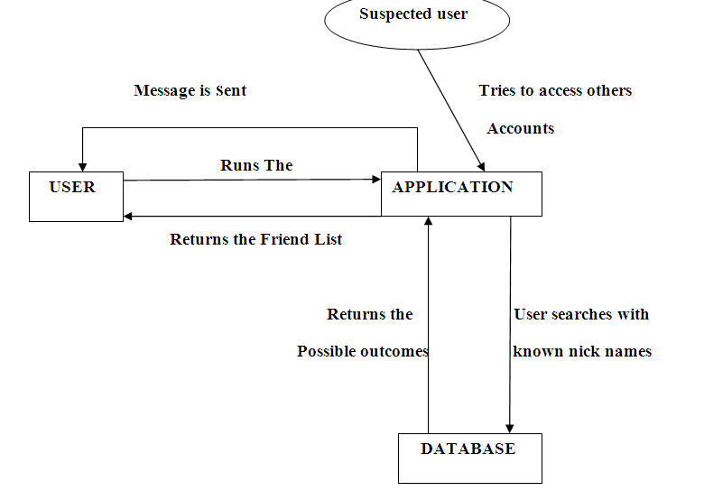Fig . 1 product perspective

3.2 System design

The different steps involved in mainly detecting the friends and preventing the suspicious activity are listed below. Our product makes uses of normal mining and database concepts in order to maintain the data. It makes use of pattern searching technology to give the intended result even when the nick names are given for searching. There are no such products available that provides proper result even on giving nick names. If unauthorized access is done to any other users account message are sent to the legal user. Here it makes use of networking protocol in order to send the messages.

The different interfaces that we make use in our applications are GUI interface. There is a GUI and no command line interface. The GUI is required for accepting the user’s username and password. When there are some exceptions raising error like entering invalid username and password, then error messages will be displayed prompting the users to re-enter the details.

The entire architecture of the application will start with the user registering for the social networking site. During the time of registration the user specifies his personal details and the most important aspect is specifying his 10-digit phone number so that he/she can receive messages upon any suspicious activity with their account.

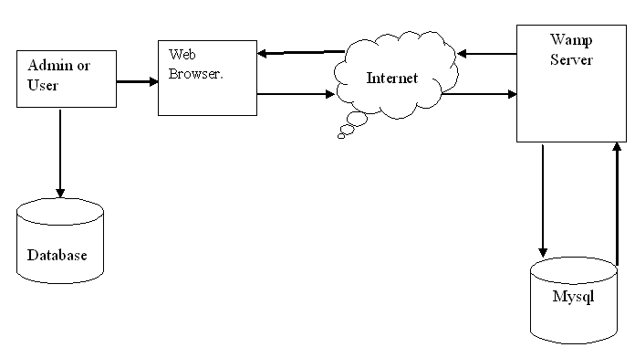
Fig. 2 system design of application

  - Working
Since the agenda of the working of the project is to detect the suspects or intruders who are trying to misuse or hack the other legally registered users. We are also trying to find the friends by giving their alias names or popular nick names in the query search so that the search efficiency is increased and time taken for search is also reduced. Most importantly number of profiles generated as the result of search query will be reduced.

Discussing about the first domain while the user is getting registered to our social site he/she during the time of registration specifies their most popular alias name or nick name. By the help of this anyone who knows their nick name can search their profile by specifying the intended name in the search query.

The second domain is to track the suspicious activity going on in the users profile. As stated above the most popular form of suspicious activity is to hack the account by guessing their passwords. The hacking of password depends on how the strength of the password the user has fixed. If the suspected intruder knows the username of the social account he/she can go on guessing the passwords without the knowledge of user.
In this scenario the user will never come to know that some suspected intruder is trying to guess their password and hack the account. In this case we are trying to track the ip address of the intruder from which he/she is trying to do this suspicious activity. A message and an email will be sent to the user to inform about the activity going on. By this we can take a step towards reducing hacking of the account and account getting misused.

IMPLEMENTATION OF SUSPECT TRACKING
Whenever you get online, your computer is assigned an IP address. If you connect through the router, all of the computers on that network will share a similar Internet Protocol address; though each computer on the network will have a unique Internet address. An IP address is the Internet Protocol (IP) address given to every computer connected to the Internet. An IP address is needed to send information; much like a street address or P.O. Box is needed to receive regular mail. Tracing an IP address is actually pretty straightforward, and even though it's not always possible to track down a specific individual, you can get enough information to take action and file a complaint.

3.3.1 Algorithm how tracking is done

Steps:
1) Administrator will be monitoring the users profile information. The login and logout times are noted and there will be proper pattern for the process.
2) Since the intruder will not know the password he/she starts guessing the password.
3) Here we are keeping the count variable. If the number of trials for passwords increases the set count the admin will take the following actions
4) Administrator sends an email and sms to the user’s number after the variable count is increased by the set value.
5) It checks and decodes all the edge pixel of the Least Significant bit alone.
6) The user after getting an email or sms he/she will be provided with the option of changing the username and password. By this the user can save his profile from suspicious activity.

4. BENEFITS OF SUSPECT TRACKING

I. It prevents the suspicious activity that are now a days going on very frequently on social networking sites.

II. The searching of friends will become easy as we are implementing the nick/alias name searching

III. Since we are tracking the Ip address of the pc from where the suspicious activity has been done, the suspect tracking becomes easy

IV. Since the user will be giving his nick/alias name during the registration that will help in reducing the number of results that are retrieved by the query.

V. If the user is not having mobile devices then he will receive the email on his id so that he can get to know the suspicious activity.

5. CHALLENGES OF TRACKING AND ALIAS IDENTIFICATION
The challenges for video Watermarking are as follows:
A. Video media is susceptible to increased attacks than any other media
B. Video content is sensitive to subjective quality and Watermarking may degrade the quality .
C. Video compression algorithms are computationally intensive and hence there is less headroom for Watermarking computation
D. Video is bandwidth hungry and that is why it is mostly carried in compressed domain. Therefore, Watermarking algorithm shall be adaptable for compress domain processing.
E. For low-bitrate video, Watermarking poses additional challenges, as there is less room for watermark data.
F. During video transmission, frame drops are very usual. If watermark data spreads over many frames, in case of frame drops, watermark data may become irretrievable. Watermarking should be robust enough against this phenomenon

- FUTURE SCOPE
As a future scope of the project the algorithm can be used in any security control centers where there are more chances of hacking.
Here we are only tracking the ip address, with the further studies in the arena the tracking of particular person can also be achieved.

- CONCLUSION
In this paper, we have proposed a light-weight web content mining system to identify aliases of a person on the Web. The proposed method is computationally efficient and seems to work for names of concealed persons, for whom there are less number of hits on the Web and there are negligible occurrences as anchor text. Presently, we are exploiting the learned aliases to develop a suspect tracking and monitoring system.

Acknowledgment

We express my sincere thanks to Head of the Department, Information Science and Engineering, for their kind co-operation for presenting the paper. I also extend my sincere thanks to all other members of the faculty of Information Science and Engineering Department and my friends for their co-operation and encouragement.

REFERENCES

- J. Artiles, J. Gonzalo, and F. Verdejo, "A testbed for people searchingstategies in the www," in Proceedings of SIGIR'05, 2005, pp. 569-570.
[2] D. Bollegala, T. Honma, Y. Matsuo, and M. Ishizuka, "Identification ofpersonal name aliases on the web," in Proceedings of 17th International Conference on World Wide Web WWW'08, Apr. 2008.
[3] C. Whitelaw, A. Kehlenbeck, N. Petrovic, and L. Ungar, "Web-scale named entity recognition," in Proceedings of 17th ACM Conference on Information and Knowledge Management (CIKM 2008), 2008.
[4] G. D. M. Rennie and T. Jaakkola, "Using term informativeness for named entity detection," in Proceedings of ACM SIGIR 2005, 2005.
[5] A. Bagga and B. Baldwin, "Entity-based cross document coreferencing using vector space model," in COLlNG'98, 1998, pp. 79-85.
[6] T. Hokama and H. Kitagawa, "Extracting mnemonic names of people from the web," in Proceedings of 9th Intlernational Conference on Asia Digital Libraries (ICADL'06), 2006, pp. 121-130.

